Frontend Development with React.js Project Documentation format.

InsightStream: Navigate the News Landscape

# 1. Introduction

Proj~~e~~ct Titl~~e:~~ InsightStream: Navigate the NewTe~~am~~ M~~e~~mbers~~:~~

Team Leader Name: THANUSH R [thanushking221103@gmail.com]

Team Member Name:GOWTHAM K [gowthamkathir029@gmail.com]

Team Member Name:VAJIP BASHA E [Vajiphulk@gmail.com]

Team Member Name:UDHAYA KUMAR K [Udhayauu185866@gmail.com]

Team Member Name:MURUGAVEL P [muruga20042004@gmail.com]

# 

ROSE

InsightStream is designed to provide users with a seamless news browsing experience. It aggregates the latest news articles from various sources, allowing users to explore trending stories, filter by category, and bookmark their favorite content.

Featu~~res:~~

* Dynamic News Feed with Real-Time Updates
* Category-Based Filtering (Politics, Sports, Tech, etc.)
* Search Functionality for Finding Specific News
* Bookmark Feature to Save Favorite Articles
* Responsive Design Optimized for All Devices
* Light/Dark Mode for Enhanced User Experience

# 3. Architecture

Component Structure~~:~~

App.js - Root component that handles routing and layout

Header.js - Navigation bar with search functionality

NewsList.js - Displays categorized news articles

NewsCard.js - Individual news item with title, image, and description

NewsDetails.js - Detailed view of a selected news article Footer.js - Provides additional links and site information

State Management:

* Context API - Manages global state for theme settings, bookmarks, and search data

Routing:

* React Router - Implemented for seamless navigation between pages

# 4. Setup Instructions

Prerequisites:

* Node.js (v18 or higher)
* npm or yarn

Installation:

1. Clone the Repository: git clone https://github.com/darunraj0071/insightstream-news-app.git cd insightstream-news-app
2. Install Dependencies: npm install
3. Create .env file (for API keys or environment variables):

REACT_APP_NEWS_API_KEY=your_api_key_here

1. Run the Application: npm start

# 5. Folder Structure

/src

├── /components

│ ├── Header.js

│ ├── NewsList.js

│ ├── NewsCard.js

│ ├── NewsDetails.js

│ └── Footer.js

├── /pages

│ ├── Home.js

│ ├── Categories.js

│ └── Bookmarks.js

├── /assets

│ ├── images

│ ├── icons

│ └── styles ├── /utils

│ ├── api.js

│ ├── helpers.js

│ └── constants.js

├── App.js

# └── index.js 6. Running the Application

Frontend Server Command~~:~~

# npm start 7. Component Documentation

Key Components:

Header: Displays navigation bar and search bar

NewsList: Fetches and renders categorized news articles

NewsCard~~:~~ Displays individual news article details

NewsDetails: Provides comprehensive details of a selected article Footer: Provides links to social media and site details

Reusable Components:

Button Component: Used for actions like "Read More" or "Bookmark"

Modal Component: Displays detailed news information in a popup

# 8. State Management

Global State~~:~~

* Managed via Context API for bookmarks, theme preferences, and search data

Local State~~:~~

* Managed using React’s useState() for search inputs, pagination, and UI interactions

# 9. User Interface

* Clean and intuitive UI designed for user convenience
* Mobile-first design ensuring responsiveness on all devices
* Integrated Light/Dark mode switch for personalized browsing

# 10. Styling

CSS Frameworks/Libraries:

* Tailwind CSS - Used for fast, responsive, and modern UI design

Theming:

* Custom light/dark theme toggle for improved accessibility

# 11. Testing

Testing Strategy:

* Jest for unit testing
* React Testing Library for component behavior testing

Code Coverage~~:~~

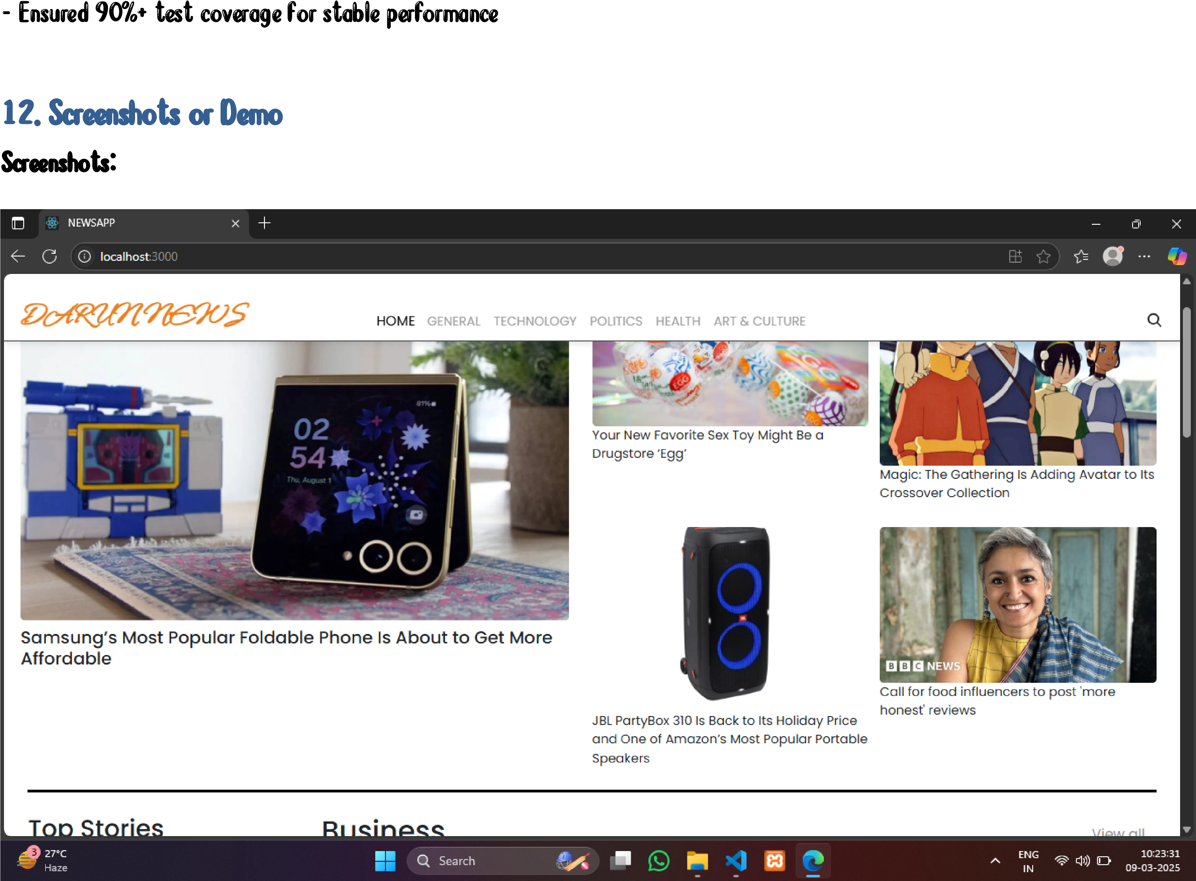

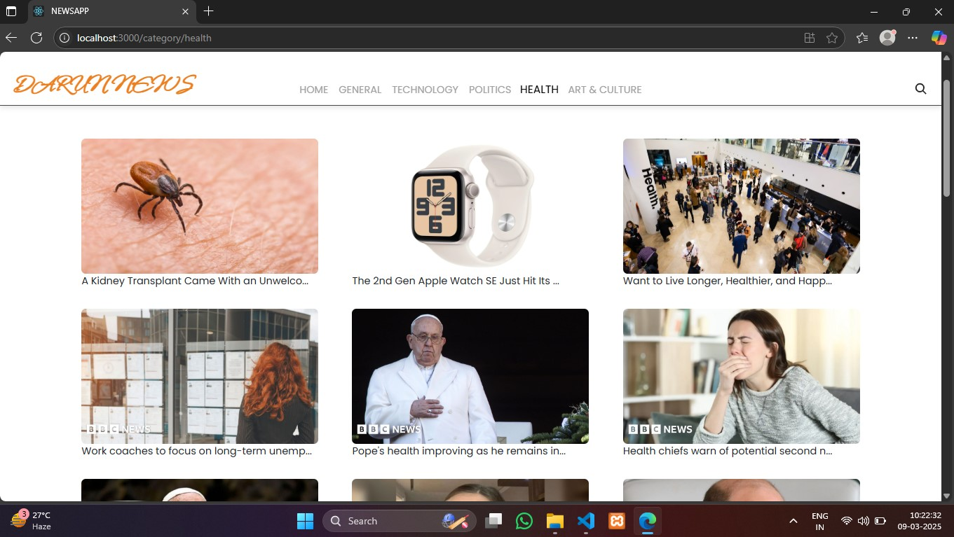

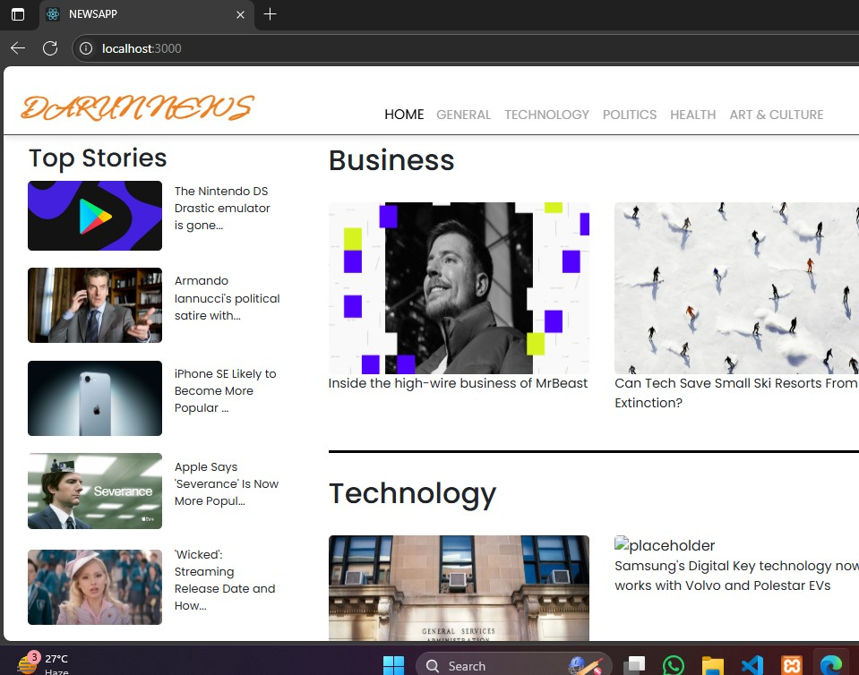

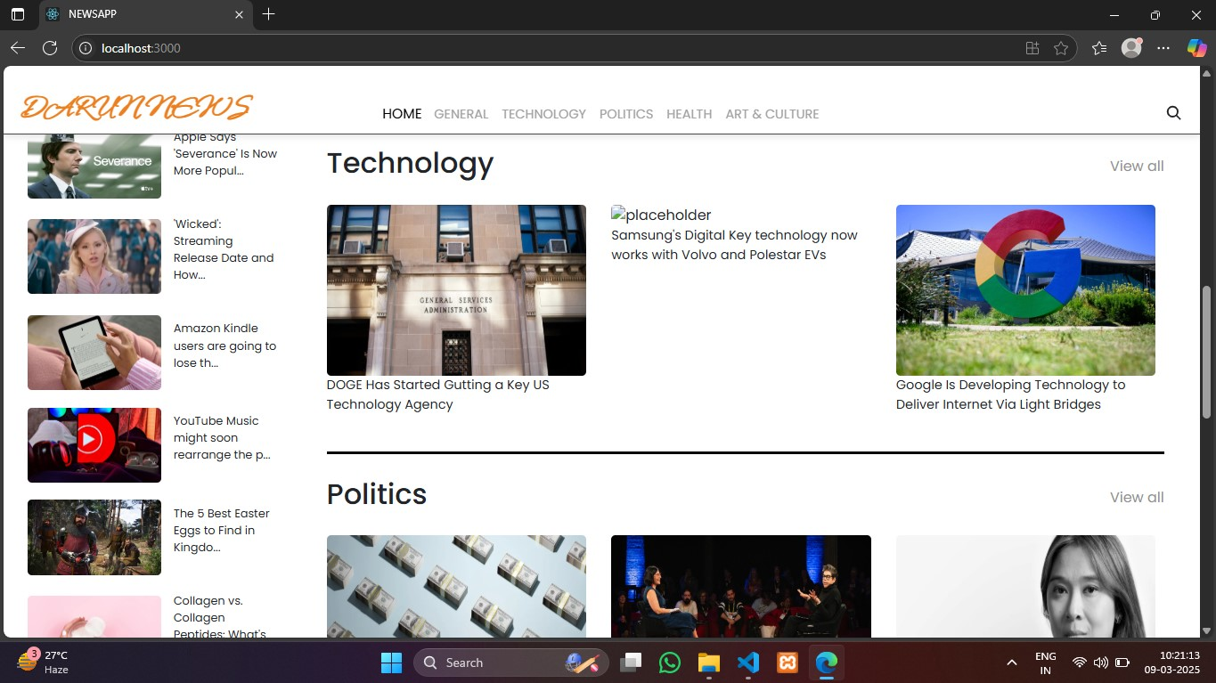

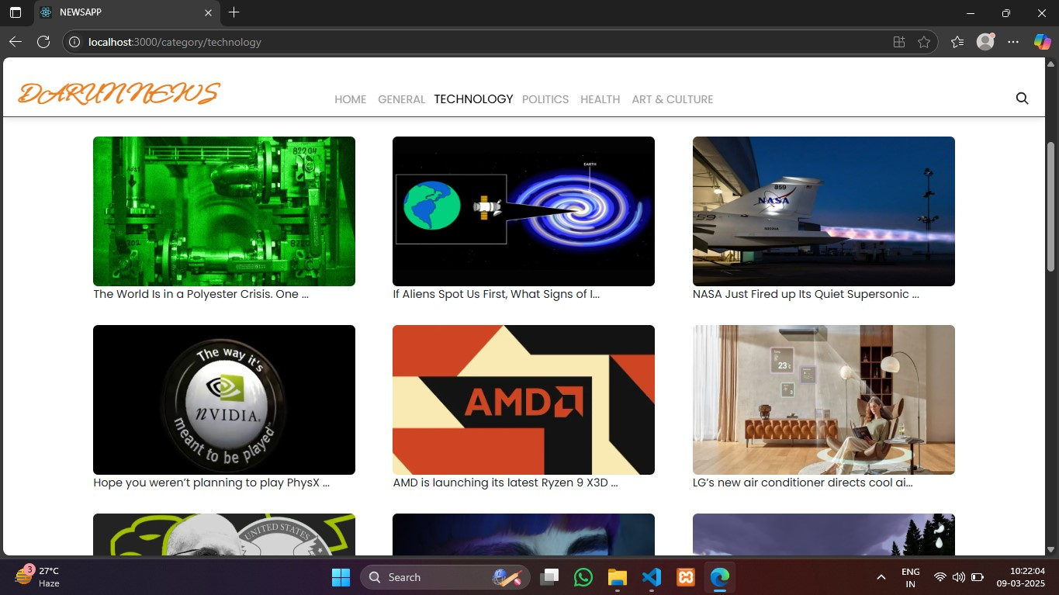

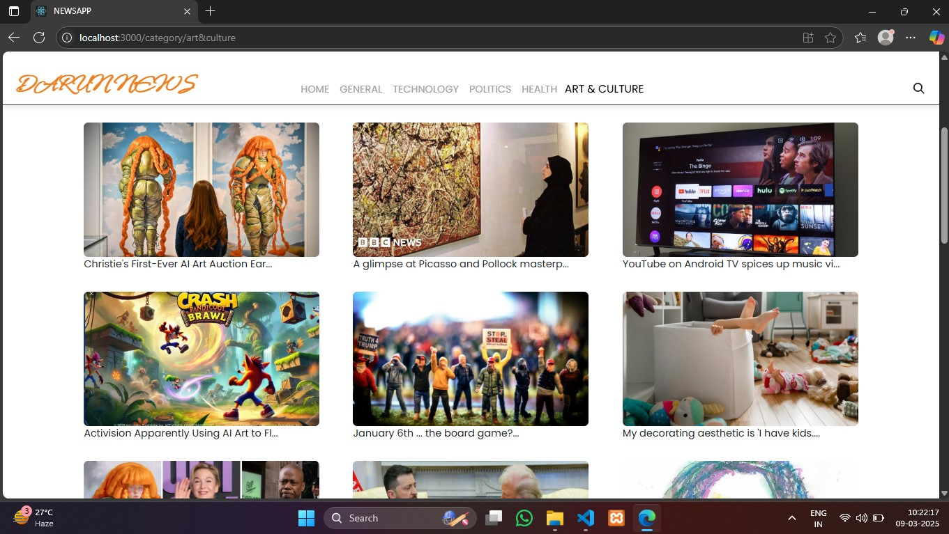

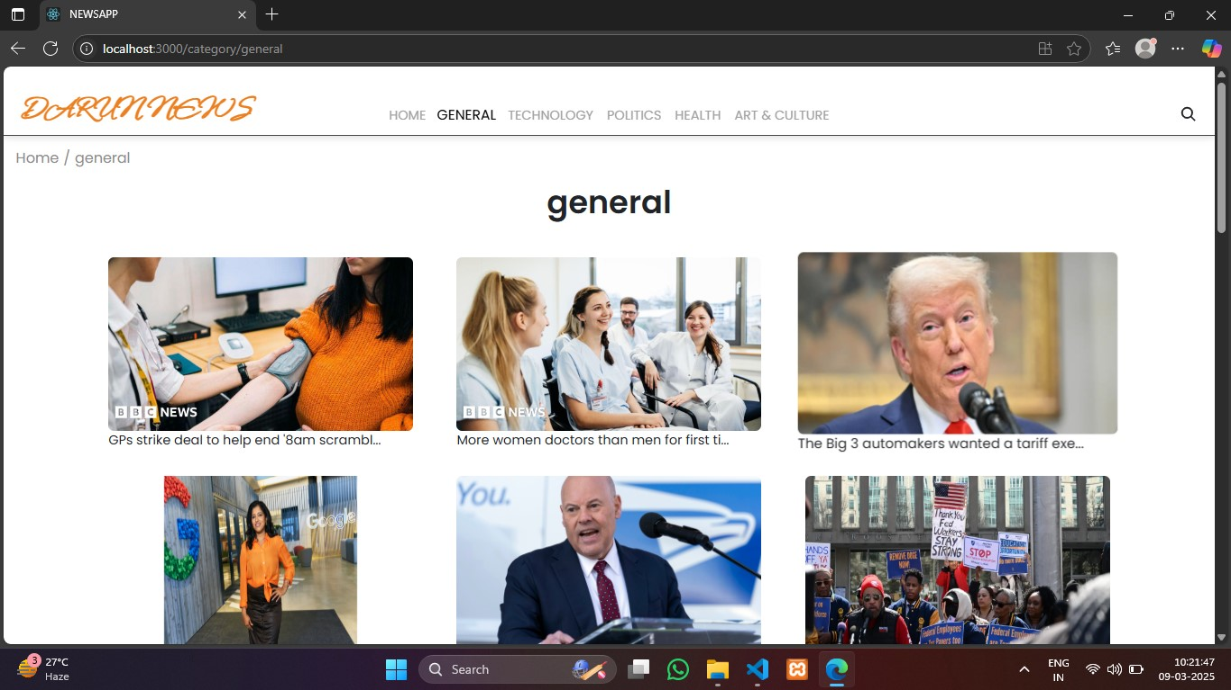

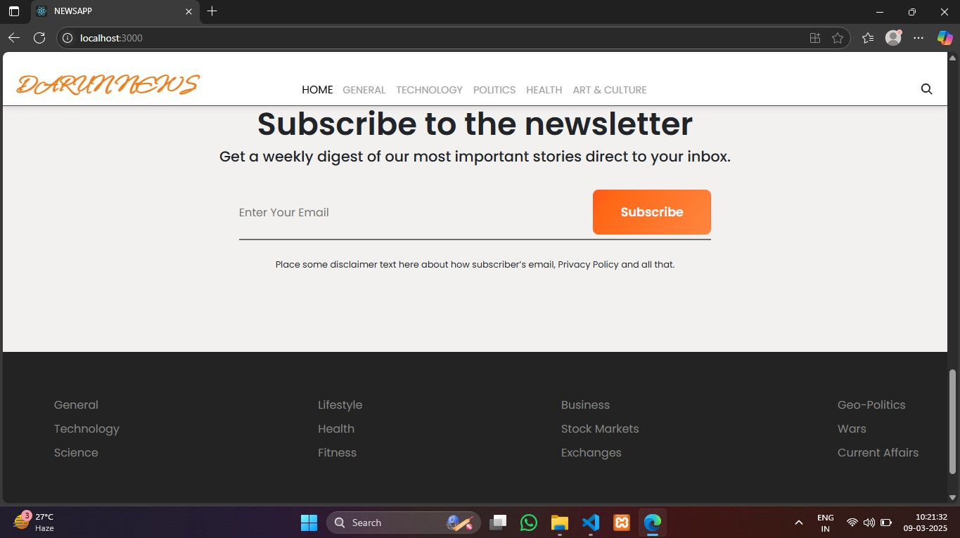

Live Demo Link:

https://drive.google.com/drive/folders/1thZ0132V1mvbHH0qfurQYmQ7ODAUXFpi

# 13. Known Issues

* Certain API endpoints may have limited access for free plans
* Bookmark feature may require additional optimization for large data sets

# 14. Future Enhancements

* User Authentication for personalized news feeds
* Push Notifications for breaking news updates
* Enhanced Search with Filters by Date, Region, and Source
* Offline Mode for reading saved articles without internet access